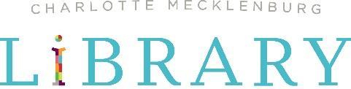

News Release
FOR IMMEDIATE RELEASE

READ, LEARN AND EXPLORE WITH THE SUMMER BREAK CHALLENGE
The Library’s popular summer learning program returns with Charlotte FC as new partner for 2022

Charlotte, NC – May 23, 2022 – Charlotte Mecklenburg Library is thrilled to announce the Charlotte Football Club, or Charlotte FC, as its new partner for Summer Break 2022, a summer literacy program that encourages reading and learning for all ages from June 1 - August 13, 2022. Pre-registration for Summer Break began Monday, May 16 and is currently open at summerbreak.cmlibrary.org.
In 2020, Summer Break introduced a new mobile app to track accounts, reading time, learning and leisure activities. Returning participants can log in with their account information from last year’s program and track their time. New participants can find the “Beanstack Tracker” app available for free download through the Google Play and Apple App stores to begin tracking their Summer Break activities on a smart phone or tablet.
“After a tough couple of years with the COVID-19 pandemic, the Library is excited to present Summer Break to the community. Summertime poses the most academic risk because students without access to summer learning opportunities can fall behind their peers, creating an achievement gap that is hard to close,” says Emily Nanney, associate director of education programs at Charlotte Mecklenburg Library. “To keep children on track with important matters such as literacy and physical activity, the Library offers fun programs and activities through Summer Break, our annual summer learning program that encourages everyone to read, learn and explore.

New for the 2022 program, Charlotte FC will join as a sponsor through their Greater Goals program. As part of this partnership, Charlotte FC and Library-branded stickers will be provided to participants of all ages at sign-up, in addition to a coupon for a free Wendy’s Jr. Frosty. Additionally, 20 two-packs of tickets to an upcoming Charlotte FC match will be awarded to one program completer at each Library location. The winner of these tickets will be selected via a random drawing on Beanstack at the end of the program.

Summer Break participants complete the program by earning 1200 points. One (1) minute of reading equals one (1) point. At least 600 points must be earned by reading (equal to 10 hours). All Summer Break participants can earn a prize upon program completion while supplies last. Prize distribution information will be announced at a later date. For more information, please visit cmlibrary.org/summer-break.

The 2022 Summer Break program is brought to you by Charlotte Mecklenburg Library. Additional support comes from Wendy’s, the Charlotte Mecklenburg Library Foundation and Charlotte Football Club’s Greater Goals.
###

Photo caption: Sign up for the Summer Break Challenge with Charlotte Mecklenburg Library starting May 16, 2022.

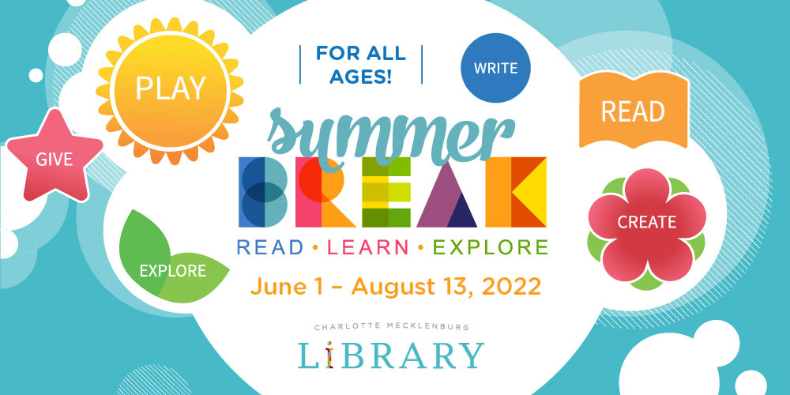

About Charlotte Mecklenburg Library:
Charlotte Mecklenburg Library is one of America’s leading urban public libraries, serving a community of more than one million citizens in Mecklenburg County, North Carolina. Through 20 locations, targeted outreach and online resources, the Library delivers exceptional services and programs, with a mission to improve lives and build a stronger community. For more, visit cmlibrary.org.

Media Contact:
Darrell Anderson
Marketing & Communications Specialist
Charlotte Mecklenburg Library
O. 704-416-0701 C. 704-302-6312

Media resources:
Charlotte Mecklenburg Library newsroom: cmlibrary.org/library-news

Social sharing:
Hashtags: #cmlibrary #CMLibrarySummerBreak
Facebook: www.facebook.com/cmlibrary
Twitter: @cmlibrary
Instagram: @cmlibrary
LinkedIn: www.linkedin.com/company/charlotte-mecklenburg-library

